Chapter 9 The Standard Model
Chapter Test Answers Total marks 40
A data sheet with appropriate physics constants will be provided for this test.
Question 1
a The Standard Model explains three of the four fundamental forces in terms of an exchange of force-carrying particles called gauge bosons. Complete the table below for the four forces. Gravity is completed as an example. (8 marks)

Description | Marks
1 mark for correctly completing each cell as below | 8

Force | Nature of force | Range over which force acts (m) | Force carrier  (gauge bosons)
weak nuclear | causes radioactive decay | 10⁻¹⁸ | W⁺, W⁻ and Z
electromagnetic | responsible for both electric and magnetic fields exerting forces of attraction or repulsion | infinite | photon
strong nuclear | holds the nucleus of atoms together and acts between quarks | ~10⁻¹⁵ | gluon
gravity | a force of attraction between any two objects with mass | infinite | graviton  (theoretical and unobserved)

b Rank these four fundamental forces in order of their strength from strongest to weakest. (1 mark)

Description | Marks
All forces in correct order from strongest to weakest:  strong nuclear > electromagnetic > weak nuclear > gravity | 1

Question 2
It was observed in the 1930s that when a neutron decayed, a proton and an electron were produced. It was consistently observed that the energy of the electron was less than expected. To avoid the violation of two fundamental principles of physics, Wolfgang Pauli suggested that another particle, undetectable at the time, was produced during neutron decay. This particle was later discovered and is now called an antineutrino.
Name the two fundamental principles of physics that would have been violated if the antineutrino was not produced during neutron decay. (2 marks)

Description | Marks
The law of conservation of energy | 1
The law of conservation of momentum | 1
Question 3
Which of the four fundamental interactions (strong nuclear, weak nuclear, electromagnetic and gravity) does:
a a proton take part in? (1 mark)

Description | Marks
strong nuclear force, electromagnetic force | 1

b an electron take part in? (1 mark)

Description | Marks
electromagnetic force

c a neutron take part in? (1 mark)

Description | Marks
strong nuclear force | 1
Question 4
A neutron is composed of two down quarks and one up quark. The mass of a neutron is greater than the sum of the masses of its component quarks. Account for this discrepancy in mass. (2 marks)

Description | Marks
The higher mass of the neutron is due to the presence of gluons. | 1
Gluons are the force carriers holding the quarks together to form the neutron. | 1

Question 5
Particle accelerators have contributed significantly to our understanding of the Standard Model of particle physics. Linear accelerators accelerate charged particles to high speeds, directing them to hit a fixed target. The products and energy of the collisions are then studied.
The diagram below represents part of a linear accelerator responsible for accelerating charged particles. The cylinders are connected to an alternating current.
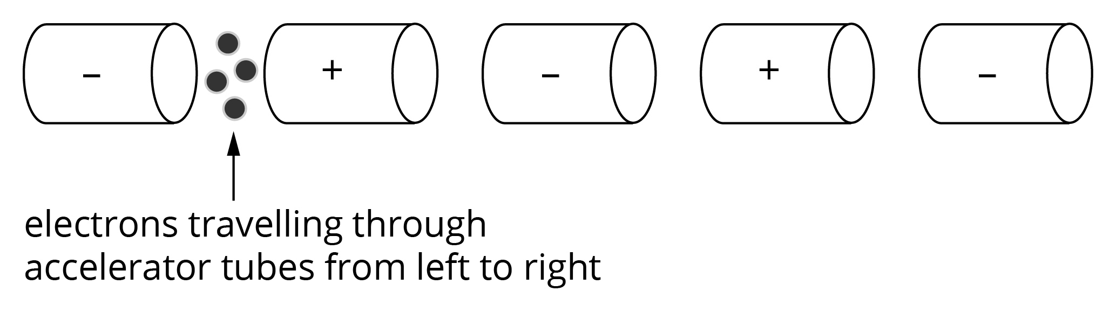
a Explain how the series of tubes accelerate the electrons. Your explanation needs to indicate the role of the alternating current. (3 marks)

Description | Marks
The electrons are attracted to the positive tube. | 1
When electrons are in the tubes, the alternating current drops to zero and reverses, repelling the electrons out the end opposite to the one they entered. | 1
The electric field between the tubes then accelerates the electrons to the next tube and the cycle repeats along the length of the accelerator, increasing the speed of the electrons. | 1

Synchrotrons are able to accelerate particles to higher speeds than linear accelerators. As well, synchrotrons allow particles travelling at the same speed in opposite directions to collide rather than only striking a fixed target.
b What advantage does the collision of particles travelling at the same speed in opposite directions provide in the study of particle physics have over a particle striking a fixed target? (3 marks)

Description | Marks
The law of conservation of momentum means that if a high-speed particle strikes a fixed target, much of its energy will be converted to the momentum of products. | 1
This limits the mass of products. | 1
The total momentum of oppositely moving particles of the same speed is zero so following collision of the particles with each other, the momentum remains zero. Thus, higher mass particles can be produced from this type of collision. | 1

c Another advantage of high-speed collisions is improved resolution to study finer structure. Explain why high speeds can achieve improved resolution. Support your answer with an appropriate equation. (2 marks)

Description | Marks
Resolution is related to wavelength of the electromagnetic radiation—higher resolution is achieved with smaller wavelength | 1
Smaller wavelength is achieved with higher momentum of the particle as shown by the de Broglie relationship: | 1

Question 6
In any particle interaction, the lepton number and baryon number must be conserved. All leptons have a lepton number of positive one (i.e. L = +1) and antileptons have a lepton number of negative one (i.e. L = −1). The table below gives leptons and their antiparticles.
Lepton | Lepton symbol | Antilepton symbol
Electron | e⁻ | e⁺
Electron neutrino
Muon | μ⁻ | μ⁺
Muon neutrino
Tau | τ⁻ | τ⁺
Tau neutrino
All baryons have a baryon number of positive one (i.e. B = +1) and antibaryons have a baryon number of negative one (i.e. B = −1). Mesons have a baryon number of zero (i.e. B = 0). The table below gives baryons, mesons and their antiparticles.
 |  | Symbol | Antiparticle symbol
Mesons | pion | π⁺ | π⁻
 |  | π° | π°
Baryons | proton | p
 | neutron | n
 | lambda | Λ°
 | sigma | Σ°

a Complete the particle interactions indicated below. Explain your choice of particle.

i μ⁻ → e⁻ + + _____ (3 marks)

Description | Marks
Allow any lepton to complete the muon decay. | 1
- prior to decay, lepton number is +1  - lepton numbers for e⁻ and are +1 and −1 respectively, so to conserve lepton number the final product must have lepton number +1 (thus any lepton possible) | 2

ii p + _____ → p + e⁻ + ν_{e} (4 marks)

Description | Marks
Allow any pion to complete the reaction. | 1
Both lepton and baryon numbers must be conserved. | 1
After the reaction, the lepton number = 0, so the missing reactant can’t be a lepton. | 1
After the reaction, the baryon number = +1.  The proton has a baryon number of +1, so the missing reactant must have a baryon number of 0 (thus, it is a pion). | 1

b Describe the particle interaction represented by the Feynman diagram below. Your description needs to name the particles and the type of force carrier involved.
(3 marks)
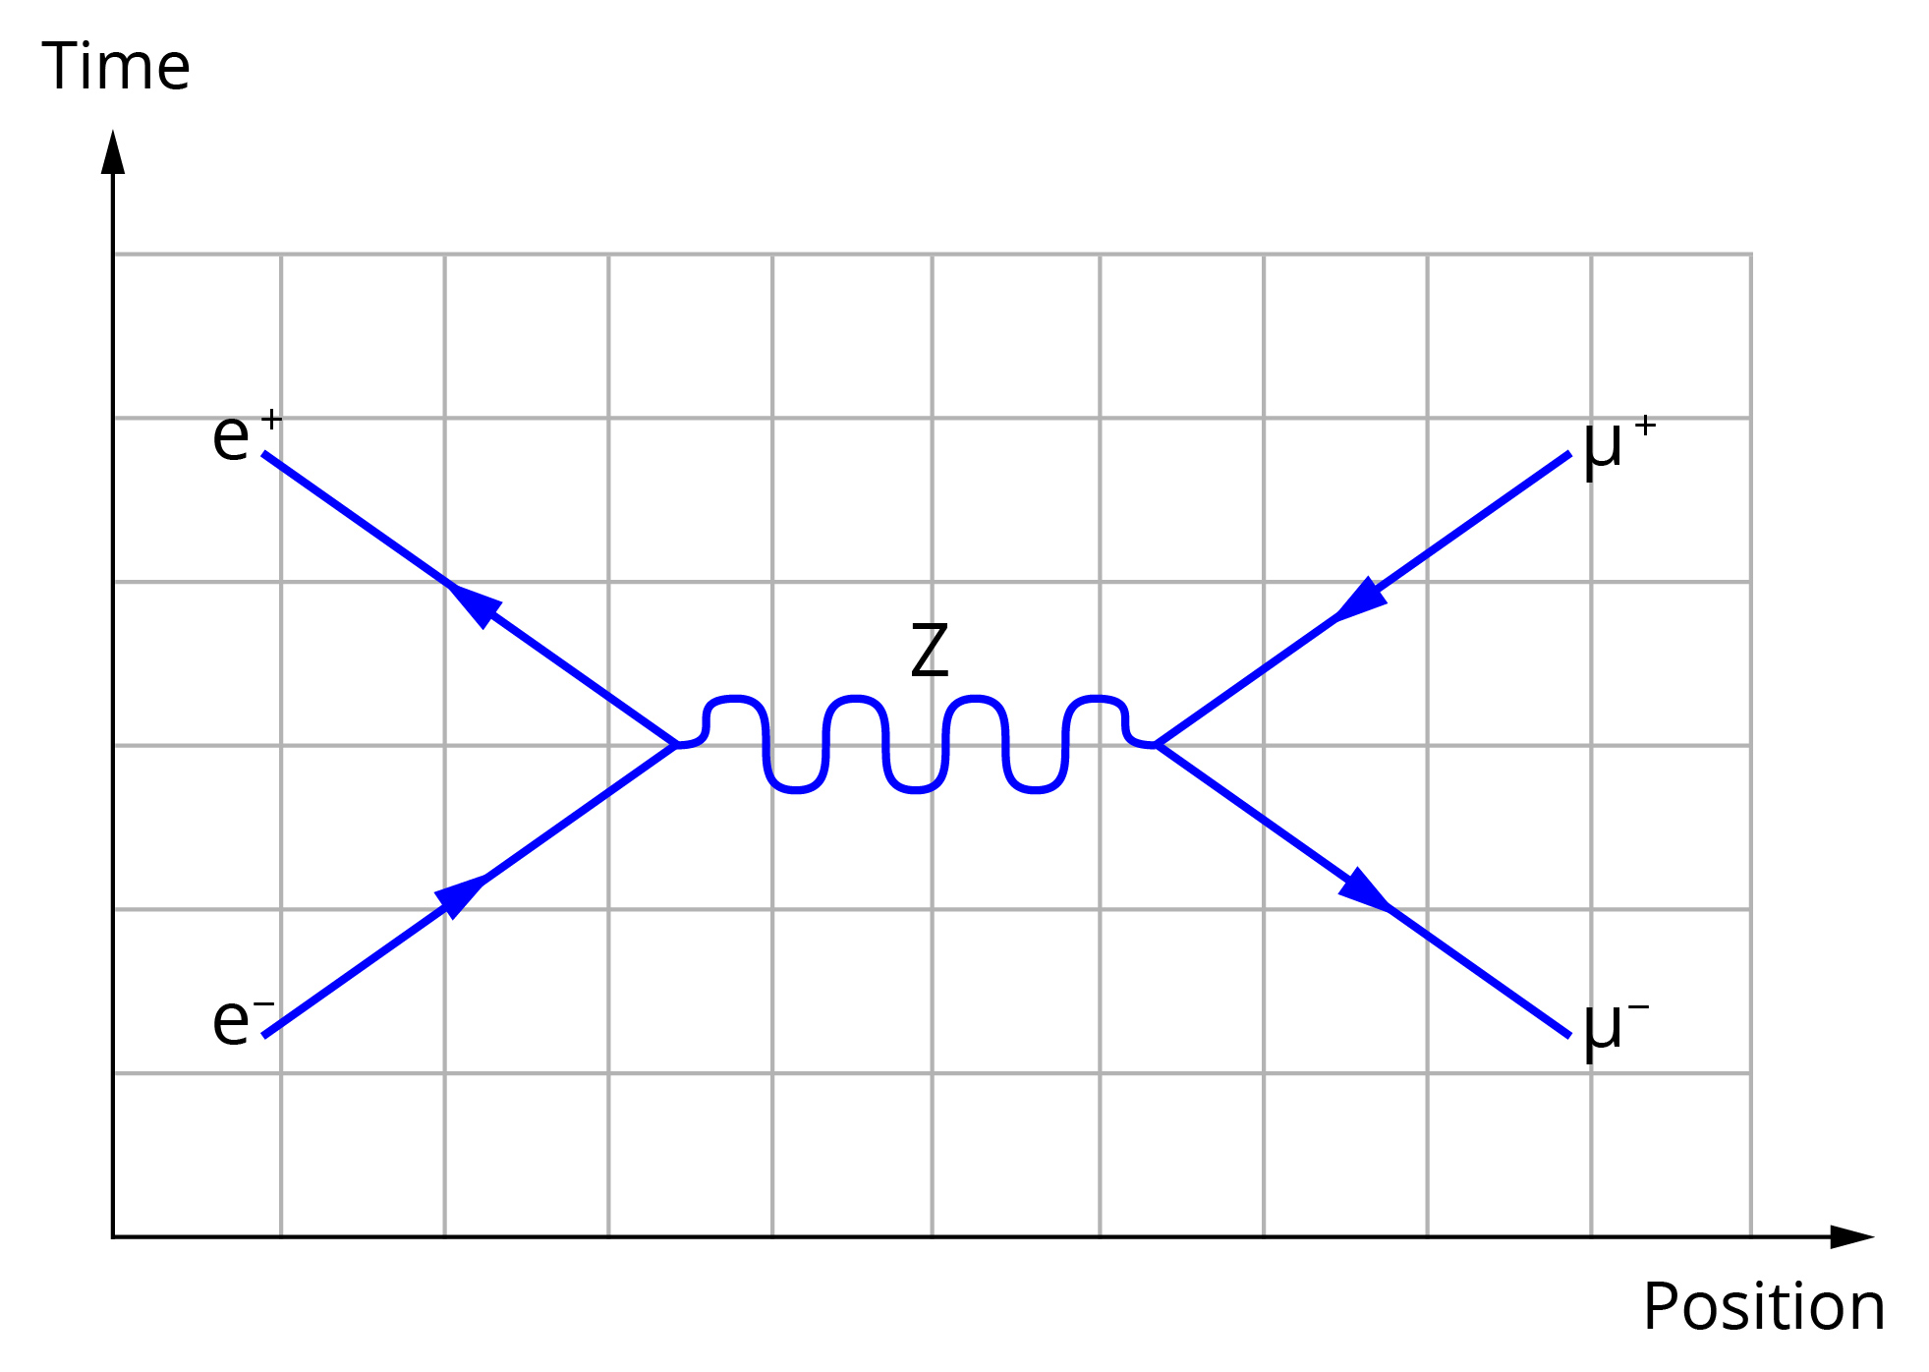
Description | Marks
An electron and a positron (electron antiparticle) collide. | 1
A weak force is released as a boson. | 1
A muon and antimuon are released from the collision. | 1

Question 7
When the red shift in the spectra from distant stars was first observed, it was interpreted as a Doppler shift. Explain why this is no longer the accepted interpretation for the red shift. Your explanation needs to indicate what causes the change in the wavelength of light that originated from distant stars. (2 marks)

Description | Marks
The red shift is now interpreted as the expansion of space. | 1
As space expands, the light expands with it causing the light’s wavelength to increase (shifting it to the red end of the spectrum). | 1
Question 8
One of the pieces of evidence found to support the Big Bang theory for the evolution of the universe is the existence of the cosmic background microwave radiation.
a Why is this radiation in the microwave region of the electromagnetic spectrum?
(2 marks)

Description | Marks
When the Universe began with the Big Bang, the radiation would have had a much smaller wavelength (high-energy gamma radiation). | 1
As space expanded, the wavelength of the radiation increased with space. | 1

In 1964 Arno Penzias and Robert Wilson measured uniform background radiation in all directions and so discovered the cosmic background radiation. Later, more detailed measurement has shown small variations in the temperature of the cosmic background radiation.
b Why is this small variation in temperature important in explaining the universe as it is observed to exist? (2 marks)

Description | Marks
If the background radiation were uniform, no stars or galaxies could form. | 1
The variation allows for ‘clumping’ of matter due to localised gravitational fields that can draw matter to them to form stars and galaxies. | 1

